The Grange Primary
Whole School Reading Spine 2025-2026
 | Autumn One | Autumn Two | Spring One | Spring Two | Summer One | Summer Two
Class 9  English Texts | Grammar Place Value Unit | The Great Fire  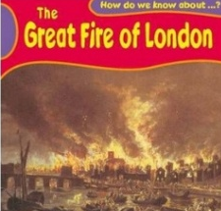 | 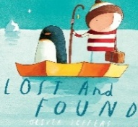  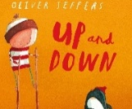  Lost and Found  Up and Down | Castles  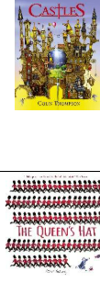 | The Queen's Hat | Man on the Moon  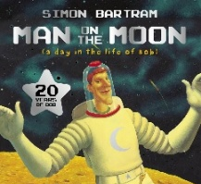
Class 9  Class Novels/ Favourite 5 | Ratburger | Human Body (NF)  Clever Camouflage (NF)  Hidden Hibernators (NF)  What’s under your hat?(Poetry) | Rameena’s Ramadan (Twinkl)  Buried Alive!  Mr Grin and Mr Groan (Poetry) | Mother’s and Others’ Day  Castles (NF)  Villainous Victorians  The Diary of a Killer Cat Mrs White Had A Fright | The Royal Baby’s Big Red Bus  Macbeth  Queen Elizabeth(NF)  A Saucepan On His Head (Poetry) | Hetty’s Hanukkah  Cookie’s Christmas Invention  A festive Feast  The Big Father’s Day Barbecue  Don’t Hit Your Sister
Class 10  English Texts | Grammar Place Value Unit  supported by:  Alan’s Big Scary Teeth | The Great Fire  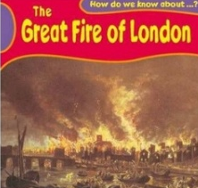 | 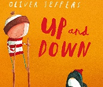  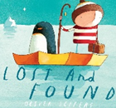  Lost and Found  Up and Down | Castles | The Queen's Hat | 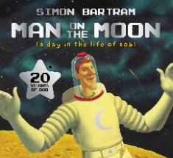  Man on the Moon
Class 10  Class Novels | Class books are selected based on the children’s interest at the current time. Children take it in turns to select a short novel for the rest of the class to enjoy.
Class 12  English Texts | Grammar Place Value Unit | 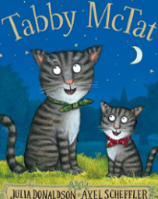  Tabby McTat | The Scarecrow’s Wedding  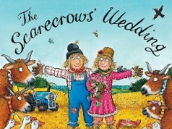 | 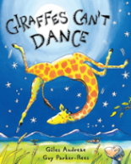  Giraffe’s  Can’t  Dance | 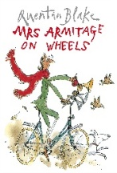  Mrs Armitage  on Wheels | 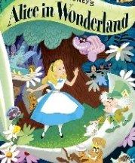  Alice in Wonderland
Class 12  Class Novels/ Favourite 5 | Too Many Babies | Stick Man  The Gruffalo  The Gruffalo’s Child  Geronimo  Lost and Found | The King in the Forest | The King in the Forest | Robin Hood | Robin Hood
Classes 7, 8, and 11 follow the Equals Curriculum.

