The Grange Primary
Whole School Reading Spine 2025-2026

 | Autumn One | Autumn Two | Spring One | Spring Two | Summer One | Summer Two
Class 3  English Texts | Grammar Place Value Unit | 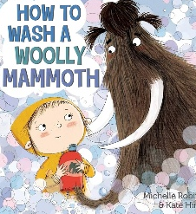  How to wash a Woolly Mammoth | 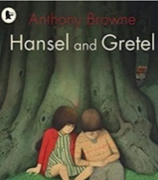  Hansel and Gretel | La Luna  (Literacy Shed  animated film) | 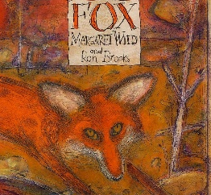  Fox | 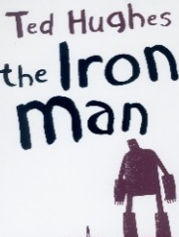  The Iron  Man
Class 3  Class Novels | Fantastic Mr Fox | The Twits | The Queen's Nose | Einstein the Penguin | Wildsmith | 13 Story Treehouse
Class 4  English Texts | Grammar Place Value Unit  Supported by the novel: The Barnabus Project | How UK Parliament works (NF)  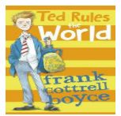  Ted Rules  the World | 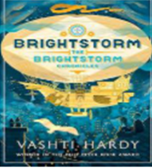  Brightstorm  Greek Myths | Dark Whisper  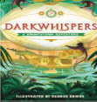 | Escape from Pompeii  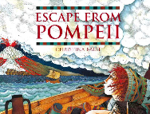  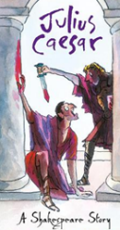  Julias Caesar | 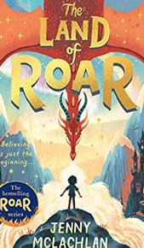  The Land of Roar
Class 4  Class Novels | The Day I fell into a Fairytale.  Being You (poetry) | Ted Rules the World  Michael Rosen: A-Z Poetry Book | Brightstorm  Choral & Performance poetry. | Dark Whisper  Outside in: Nature Poems | The Land of Roar  My Heart is a Poem: Collection of poems | The Land of Roar  Poems Aloud: Joseph Coelho
Class 5  English Texts | Grammar Place Value Unit  Supported by the novel: Way Home | 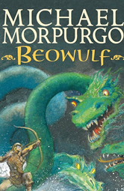  Beowulf | Macbeth  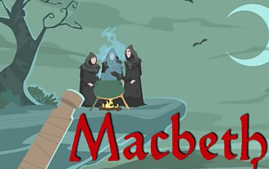 | 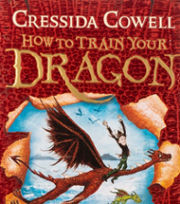  How to Train Your Dragon | Nowhere Emporium  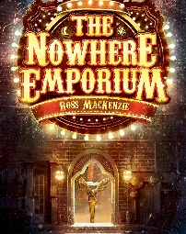 | 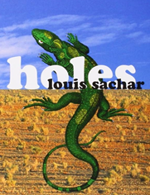  Holes
Class 5  Class Novels | Cosmic  Cloud Soup  Moon Juice (poetry) | Room 13  The Day I Fell Down the Toilet (poetry) | The Explorer  Colossal Words  (poetry) | The Explorer  Werewolf Club Rules (poetry) | Nowhere Emporium  Overheard in a Tower Block (poetry) | Holes  Bright Bursts of Colour  (poetry)
Class 6  English Texts | Grammar Place Value Unit  Supported by the novel: Oi Frog! | 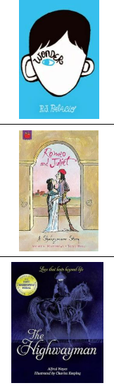  Wonder | Romeo & Juliet | The Highwayman | Beyond the Lines  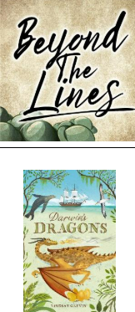 | Darwin’s Dragons
Class 6  Class Novels | Small Steps | Wonder | Tales from Shakespeare | Oh Maya Gods! | When the Sky Falls | Darwin’s Dragons

