The Grange Primary
Whole School Reading Spine 2025-2026

 | Autumn One | Autumn Two | Spring One | Spring Two | Summer One | Summer Two
Class One  English Texts | 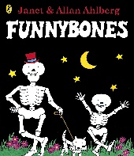  Variety of Traditional Tales  Funny Bones | 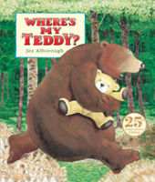  Little Bear  Stories  Where’s My Teddy  Looking at Teddies (NF) | 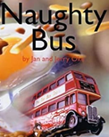  The Naughty Bus  The Queens Hat  The Kings Hats | 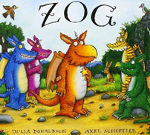  Zog  Zog and  the Flying  Doctors  Nurse Clementine | 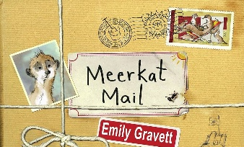  Meerkat Mail | The Secret of Black Rock  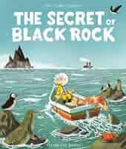  The Night Pirates
Class One  Favourite 5  Texts | Not Now Bernard  Beegu  Colour Monster  Grandad’s Secret Giant  If all the World Were | Percy Park Keeper  Rabbit’s Bad Habits  The Gruffalo  Winnie the Witch  The Last Wolf | Highway Rat  The Emperor of Absurdia  How to Catch a Star  Stanley’s Stick  That Rabbit Belongs to Emily Brown | Handa’s Surprise  Little Dreams Big People: David Attenborough  The Ugly Five  A Planet Full of Plastic  The Jungle Run | Coming to England  The Building Boy  You Can’t take an Elephant on the Bus  Supertato  Captain Flynn and the Pirate Dinosaurs | Elmer  What the Ladybird Heard at the Seaside  The Storm Whale  Blown Away  Pirate Stew
Class Two  English Texts | 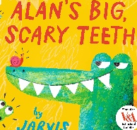  Alan’s Big Scary Teeth  Grammar Place Value Unit | The Great Fire (NF)  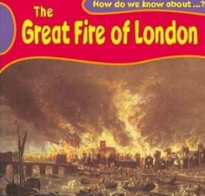 | The Great Explorer  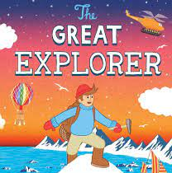 | Little Red  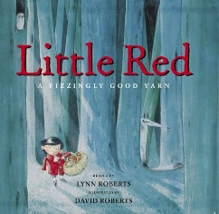 | Man on the Moon  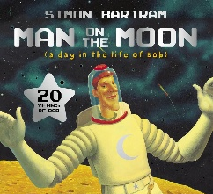 | 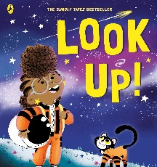  Look Up!
Class Two  Favourite 5  Texts | The Owl Who Was Afraid of the Dark  Diary of a Wombat  Why Should I Help?  No-Bot The Robot  First Book Of Nature | The BFG  Great Fire of London  Beegu  Simon Sock  First Book Of Nature | The Hodgeheg  The Snow Queen  Beware of The Bears  Trapped in The Ice  The True Story of the Three Little Pigs  First Book Of Nature | The Queen’s Knickers  Horrid Henry  Dandylion  The Day the Crayons Quit  The Dragon Machine  First Book Of Nature | Bob’s Best Ever Friend  The King of Space  Dr Xargles…  Pirates Next Door  First Book Of Nature | Traction Man  Soggy  The Sand Horse  Cool as a Cucumber  Gorrilla  First Book Of Nature

